Unit 8 – Lesson 4. Movements in VR

Aim: How do we create a simple VR cardboard Android app?
Objectives: After the lesson, students will be able to:
- Obtain basic understanding of GVR
- Set up a simple VR android app

Reference:
- Building Google VR Applications Using Unity
- https://unity3d.com/learn/tutorials/topics/virtual-reality/movement-vr
- https://arvrjourney.com/day-34-of-100-days-of-vr-setting-up-the-google-cardboard-in-unity-6f8ebcfa13b5

CLASS PROCEDURE:
Do Now:
Open the VR project you created last week. If the package is imported correctly, then you shall be able to see the demo projects.

Take the Flyer and Maze sample projects as examples, how to we navigate through the VR sample projects?
(Hints: https://unity3d.com/learn/tutorials/topics/virtual-reality/movement-vr)

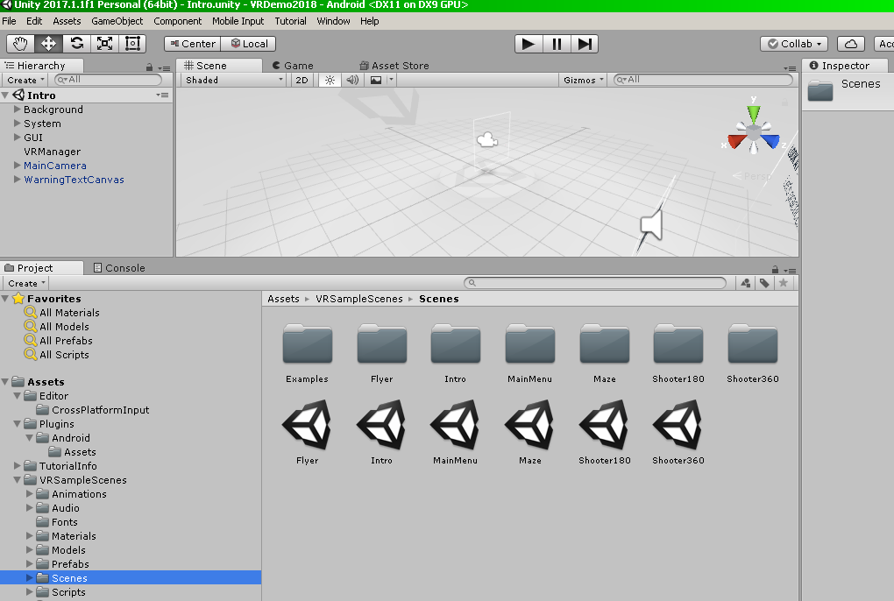

Class Discussion / Presentation:
- What are the different ways to “move” the player in the VR?

- GvrEditorEmulator for us to emulate head movement in VR
- GvrEventSystem for Unity to detect our VR inputs when we select an object
- Inside Player > Main Camera, we have our GvrPointerPhysicsRaycasterscript which allows us to use Google’s raycasting system for 3D objects
- Inside the Floor Canvas game object, we have the GvrPointerGraphicRacyate for us to interact with the UI.
- Finally, inside Player > Main Camera > GvrReticlePointer, we have our gaze cursor for Google Cardboard that we use to interact with the game world.

- What is the difference between first person game in regular games and in VR games?

Pair – sharing Activity:
Continue working on your project due Feb. 26th.

